CIS 375 – Team 3 Hotel System

Functionality Report

# Access Hotel System

* Create an account
  + Working
  + Note: the back arrow will always take you back to the parent / previous page
  + 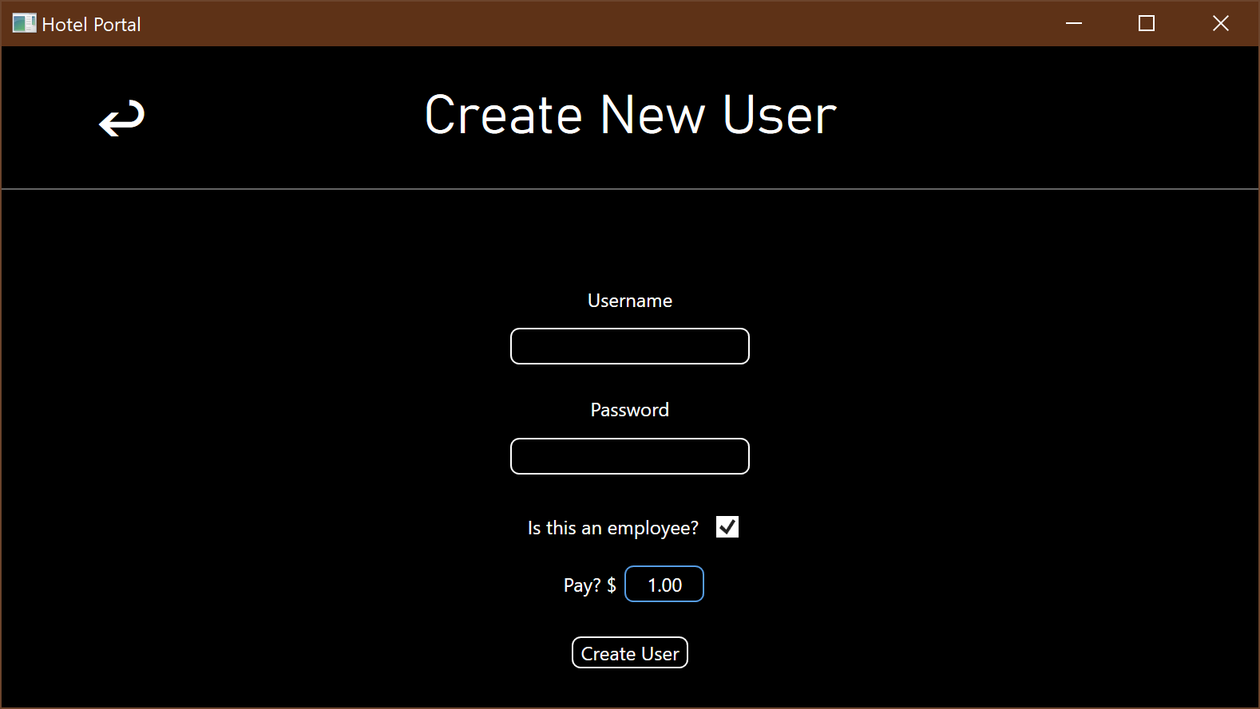
* Modify an account
  + Not Working
* Login to the account
  + Working
  + 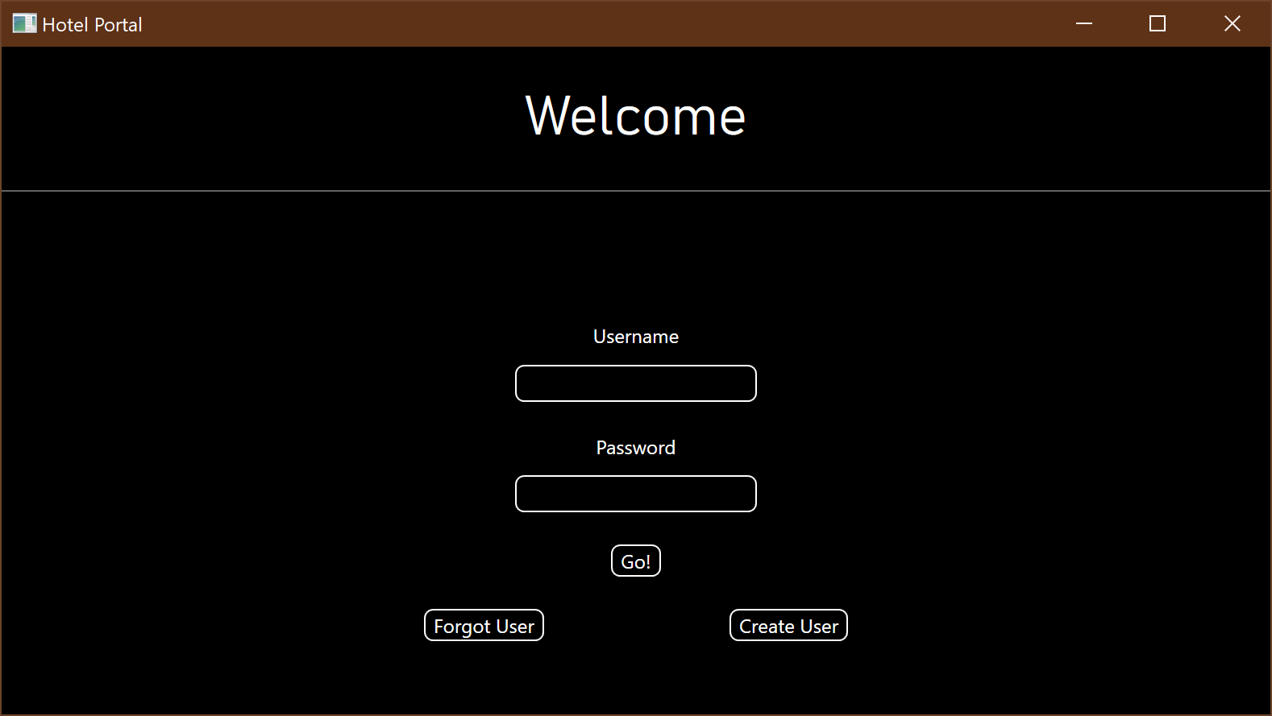
* Log out of the account
  + Working
* Retrieve account
  + Working
  + 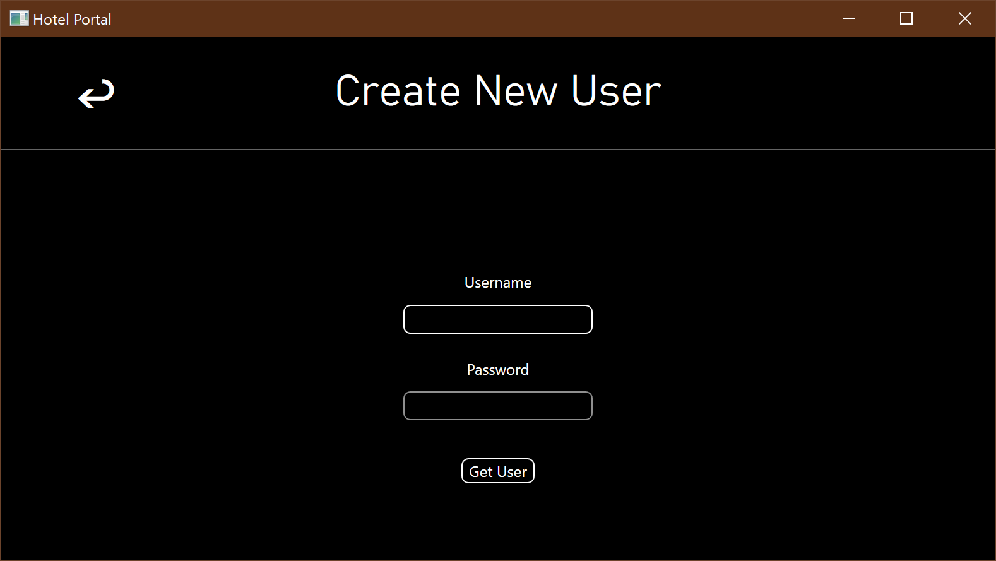

# Reservation

* Create
  + Partially Working
  + The event can be submitted and tracked in the database, but no user prompts are implemented
  + A start date can be defined, but end dates are not implemented
  + Rewards usage and accruement is not implemented
  + 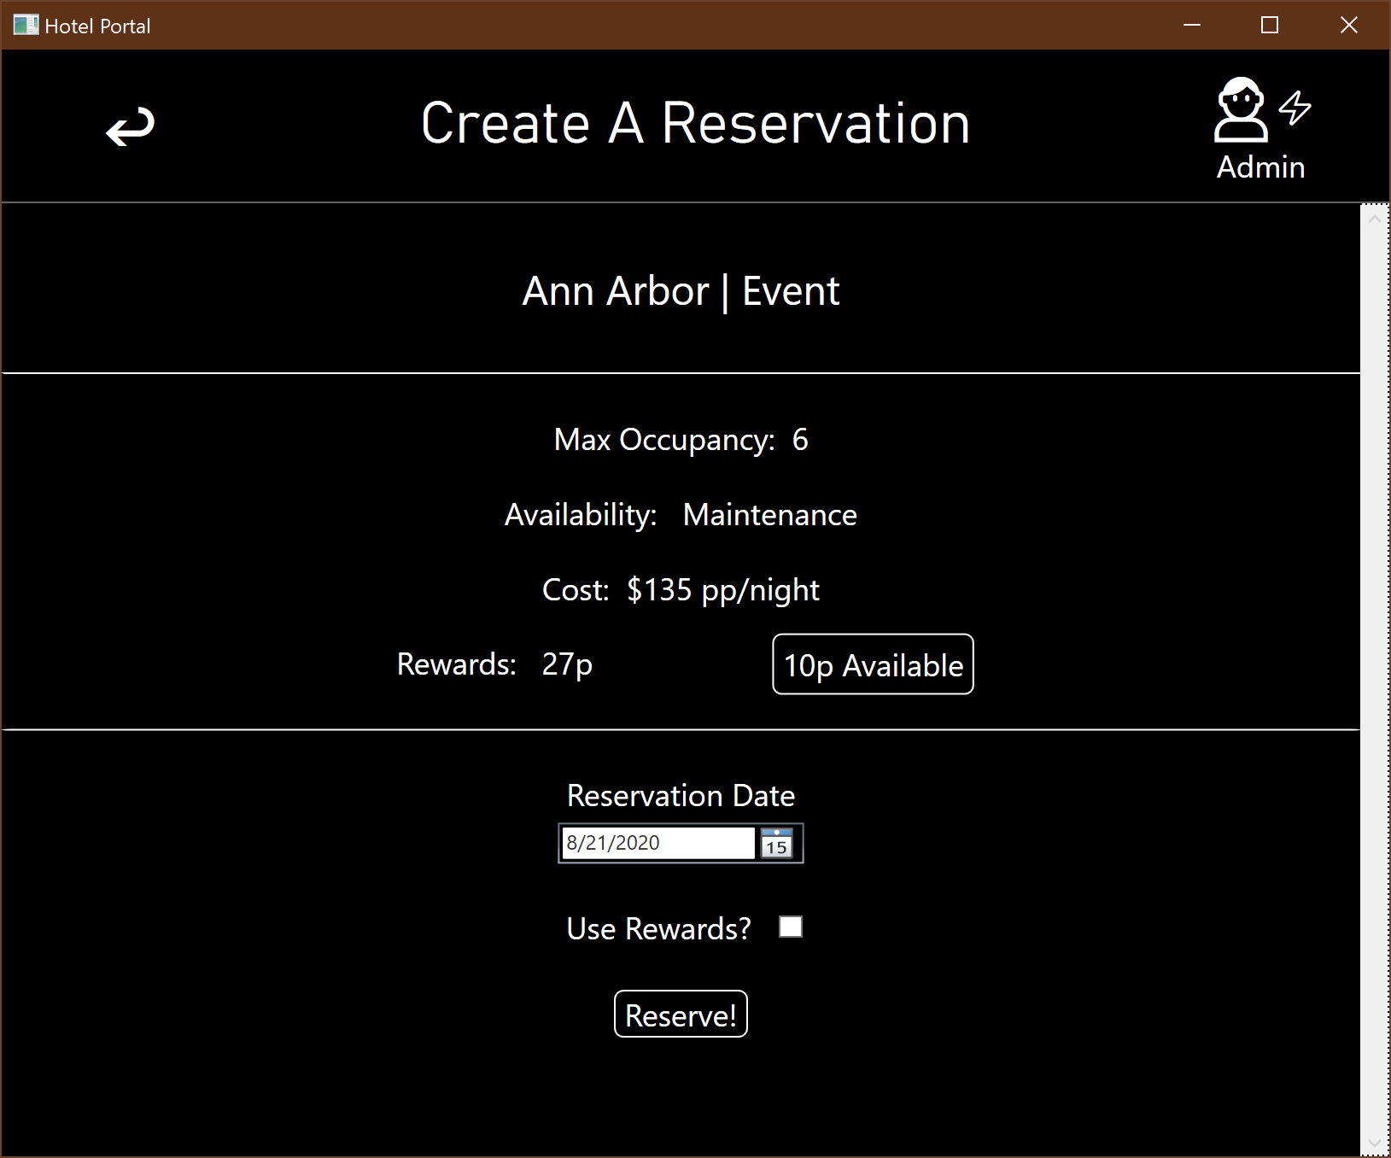
* View Hotel Info
  + Working
  + Click on the text in a tile to drill down through the hotels, rooms, and events to get to the reservation screen.
  + 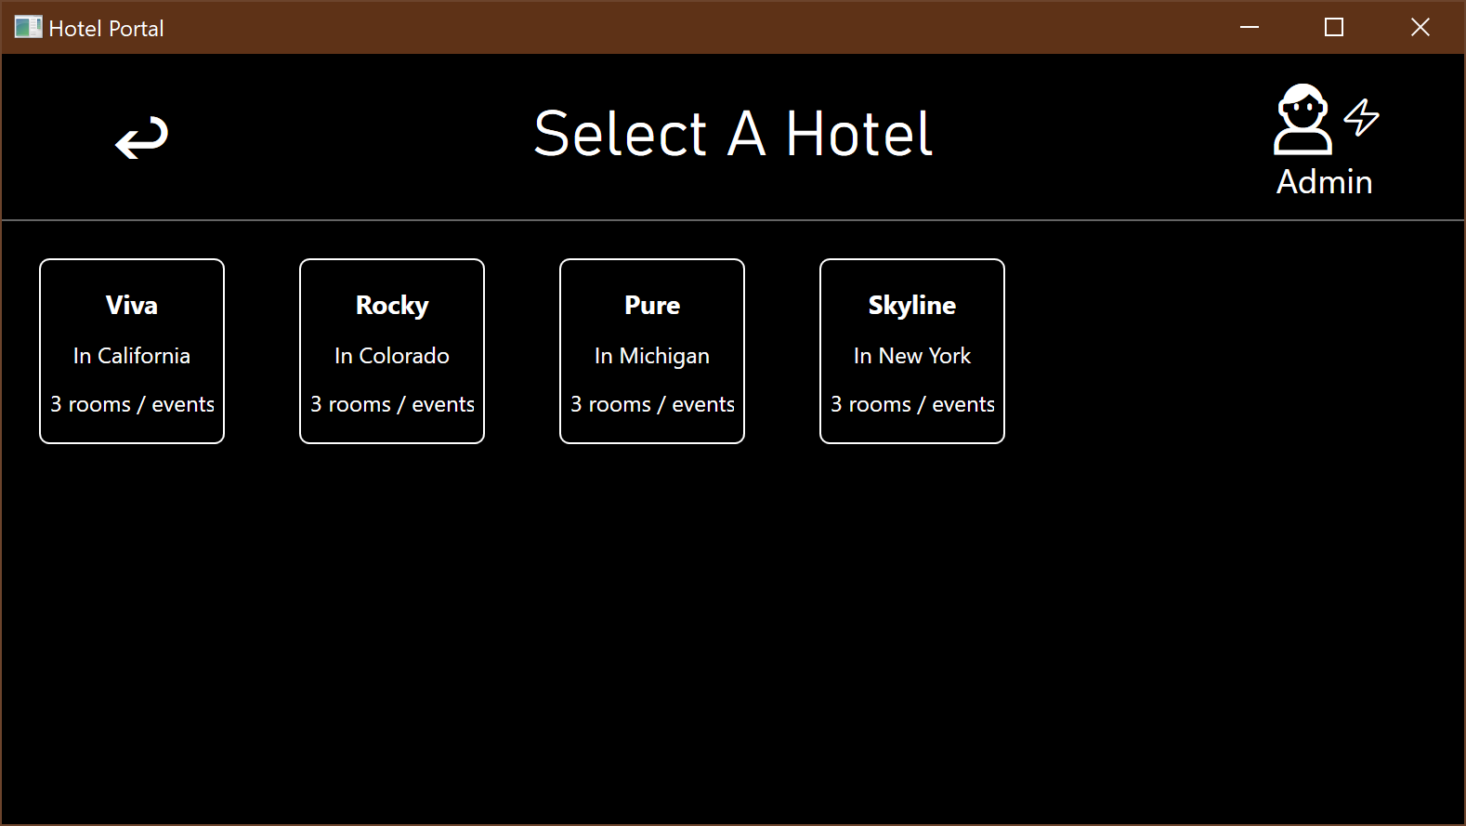
  + 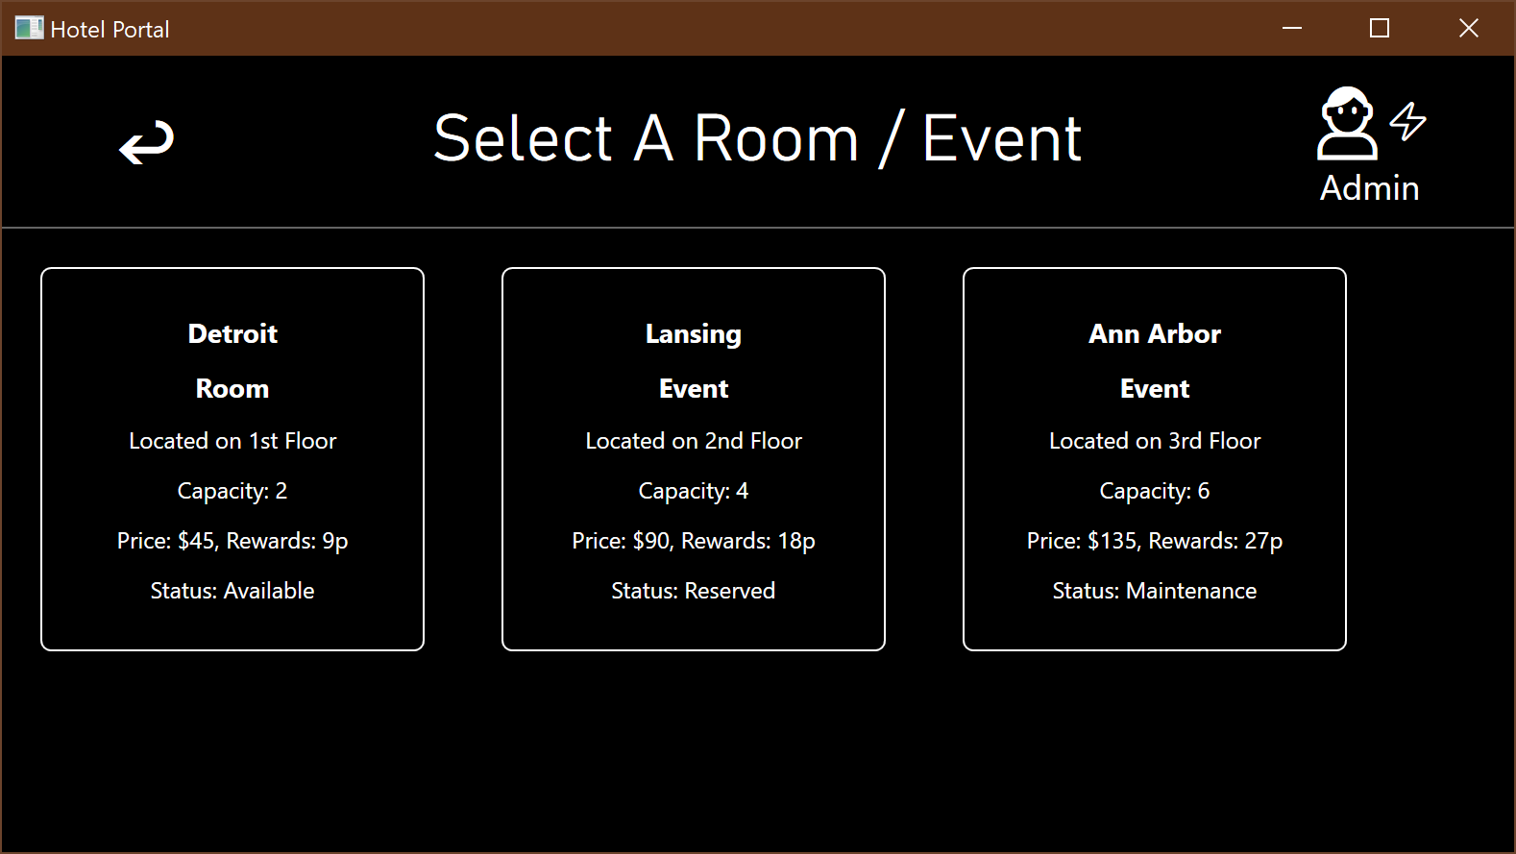
* Modify
  + Not Working
* Delete
  + Not Working
* Import 3rd Party
  + Not Working
* Waitlist
  + Not Working
* Payment Fails
  + Not Working

# Hotel Administration

* Manage hotel room / event
  + Not working
* Manage room / event costs
  + Not working
* Generate summary reports
  + Not working

# Rewards

* View / Manage Rewards
  + Not working
* Apply rewards
  + Partially working
  + Rewards can be applied if the rewards available are greater than the room / event rewards value, but reward point accruement isn’t implemented so this feature is incomplete
  + 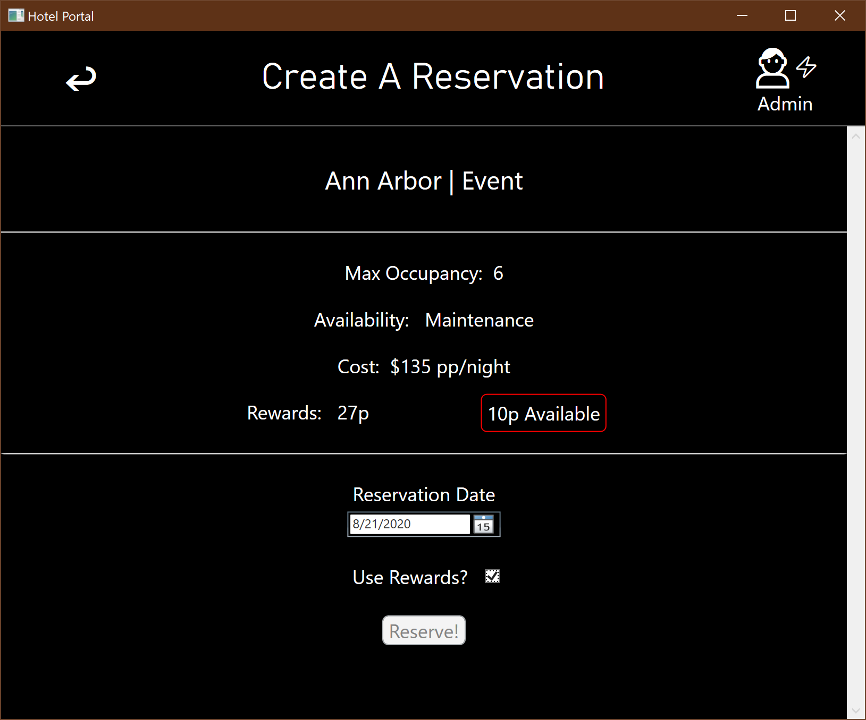
* View discounts and packages
  + Not working
* View reward history
  + Not working

# Check in / out

* Access reservation
  + Not working
* Check in
  + Not working
* Check out
  + Not working